Copper version 0.6 Installation manual

### PREPARED FOR

LK domain Registry

### PREPARED BY

R.W.D Tharanga Rajapaksha

Lanka Software Foundation

JUN 19, 2019

**Content**

Download the project version 0.6 3

Deployment 3

Primary Deployment Testing 5

Secondary Deployment Testing 5

Installation 9

Functional Testing 17

Result 19

# 

# 

# 

# 

# 

# 

# 

# 

# 

# 

# 

# 

# 1. Download the project version 0.6

Copper Email solution version 0.6 deployment manual is prepared to make it easy for anyone to follow the steps required for successful completion.

Version 0.6 can be download from the following url.

<https://github.com/LSFLK/Copper/releases>

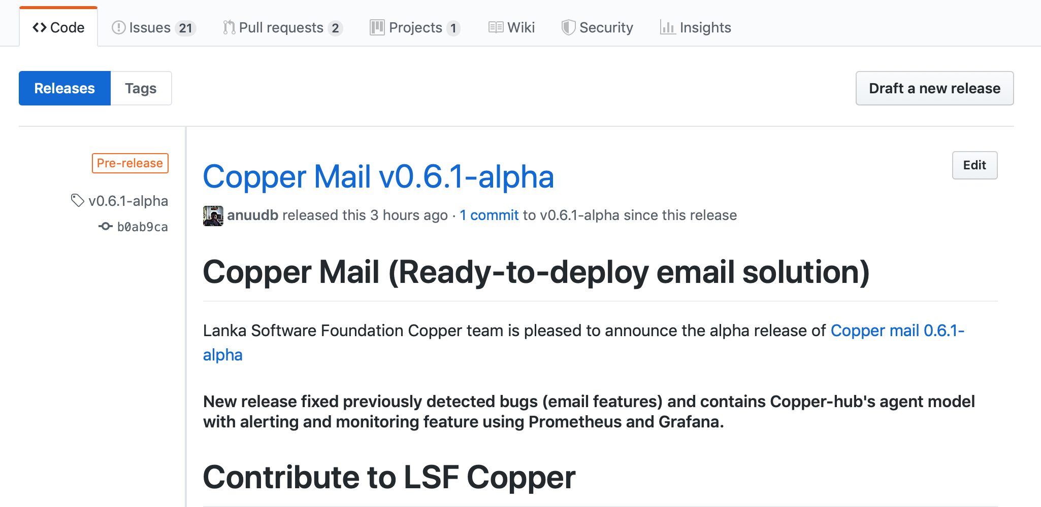

# 2. Deployment

First you have to create a folder in your server which is used as a k8s volume by copper email server.

“/data/ldap/certs”

Change to /copper/copper-server/kubernetes/deployment

Folder which has all shell script for deployment and un deployment.

If you have already deploy the system and if you want to undeploy it.

$ sh undeploy.sh

Change to deployment directory and run the deploy.sh shell script and provide necessary information. Your domain name should have 3 parts EX : copper.opensource.lk.

$ sh deploy.sh

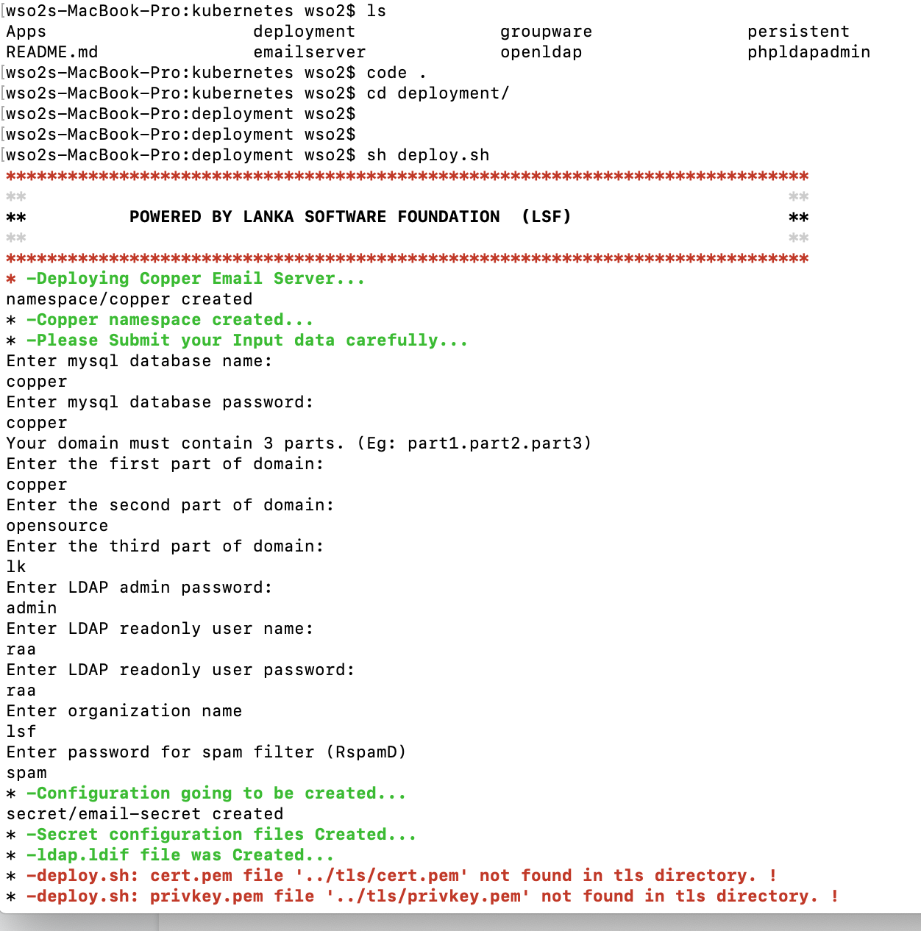

# 3. Primary Deployment Testings

Once you done the deployment then you have to check whether all pods are created and services are up and running with necessary ip allocation using following commands.

Show all pods (like vm) for the copper email solution.

$ kubectl get pods -n copper

Show all services which allow us to access each service.

$ kubectl get services -n copper

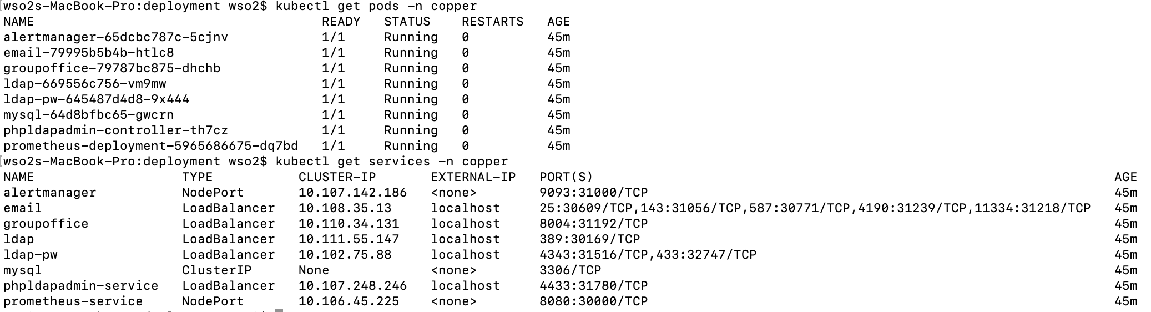

In services External-IP and the port should be used to access each service.

# 4. Secondary Deployment Testings

Now it is must to check your interfaces.

Basically there are 4 interfaces to be checked .

1. Web client interface
2. Phpldapadmin interface
3. Password change interface
4. Rspamd interface
5. **Web client interface**

You should be able to see the installation interface of group office.

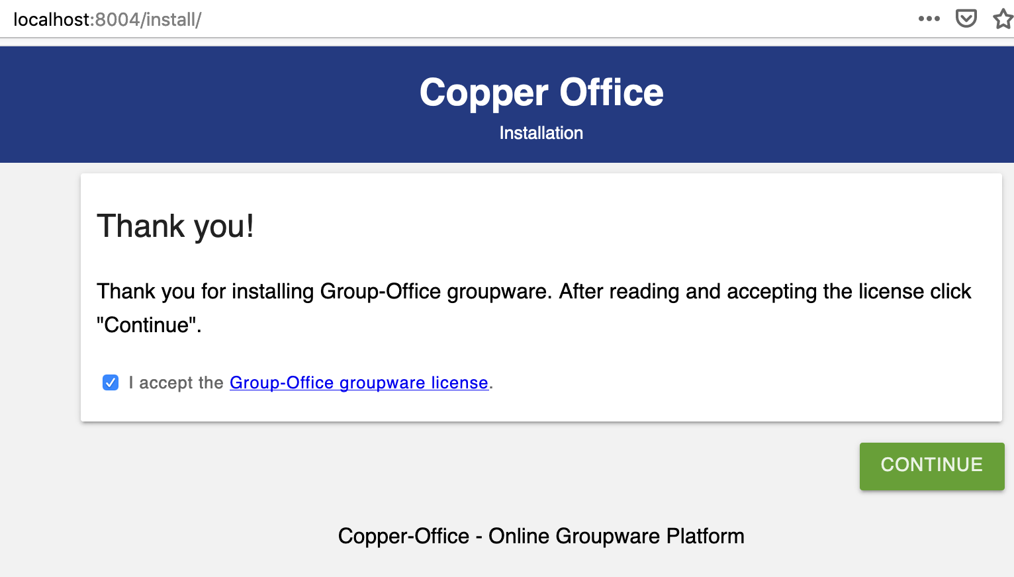

**2. Phpldapadmin interface**

<https://localhost:4433/>

You may want to accept the certificate due to those certificates are self signed.

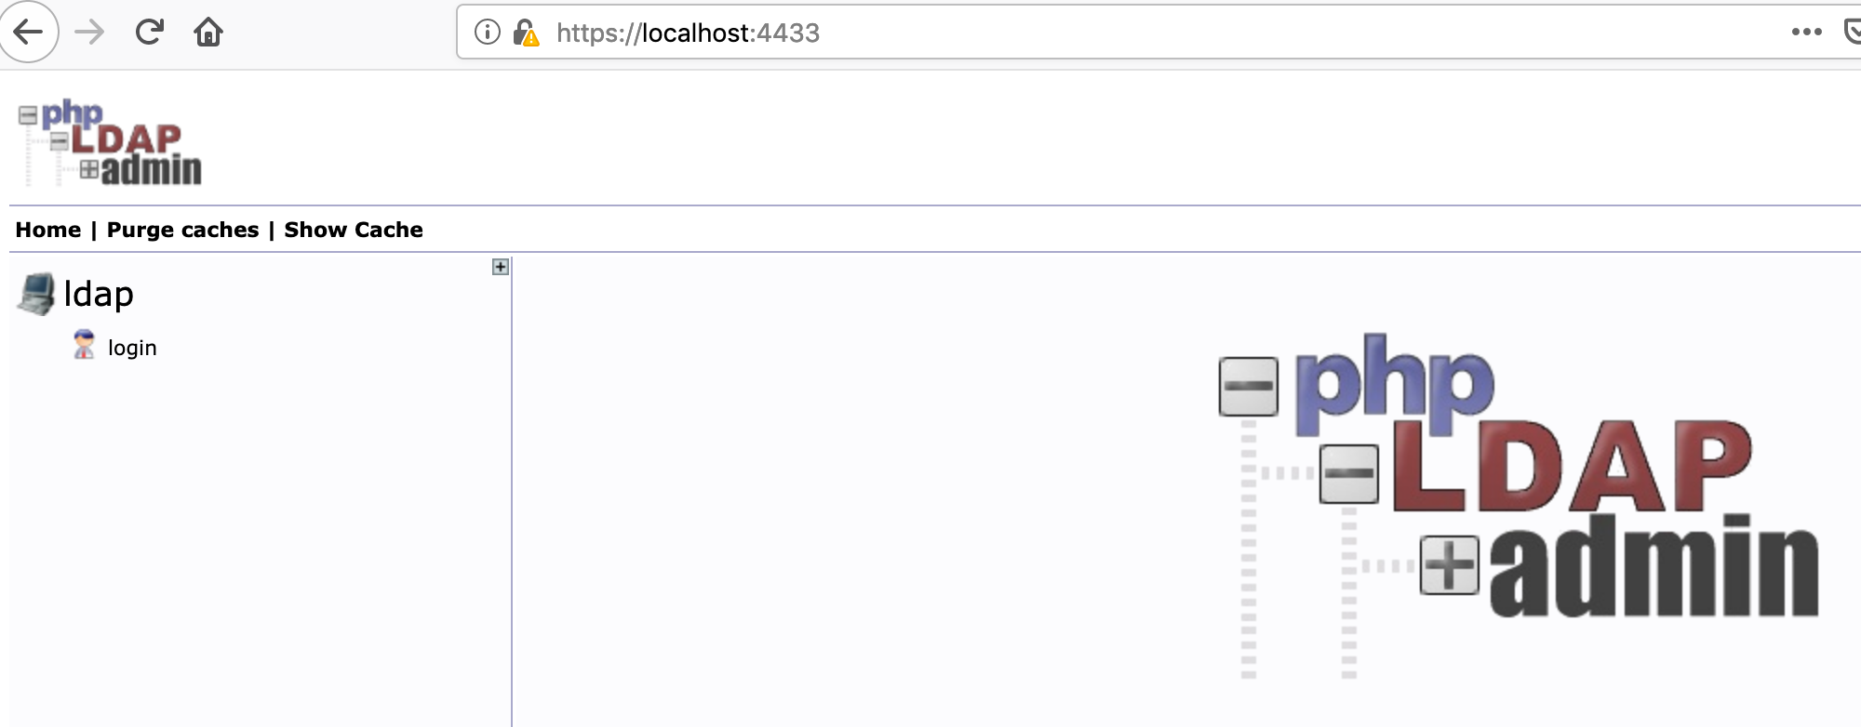

**3. Password changing interface.**

<https://localhost:4343/service/>

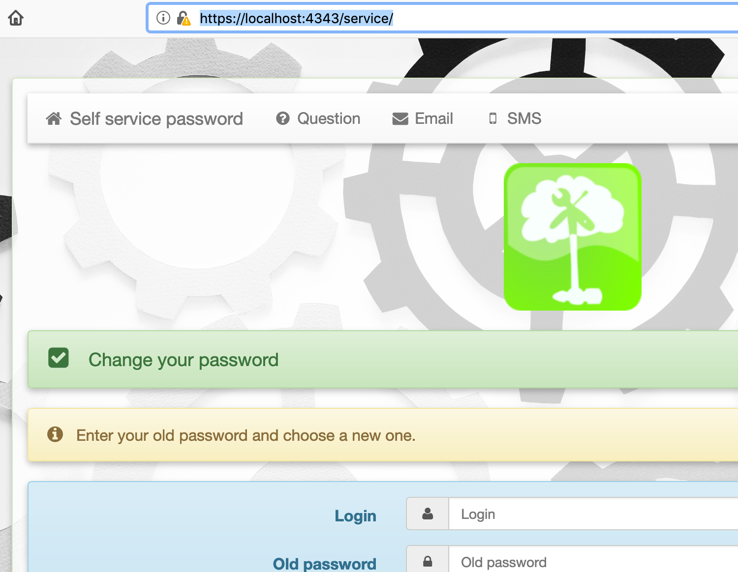

**4. RspamD interface**

Finally you should have access to the RspamD interface too.

<http://localhost:11334/>

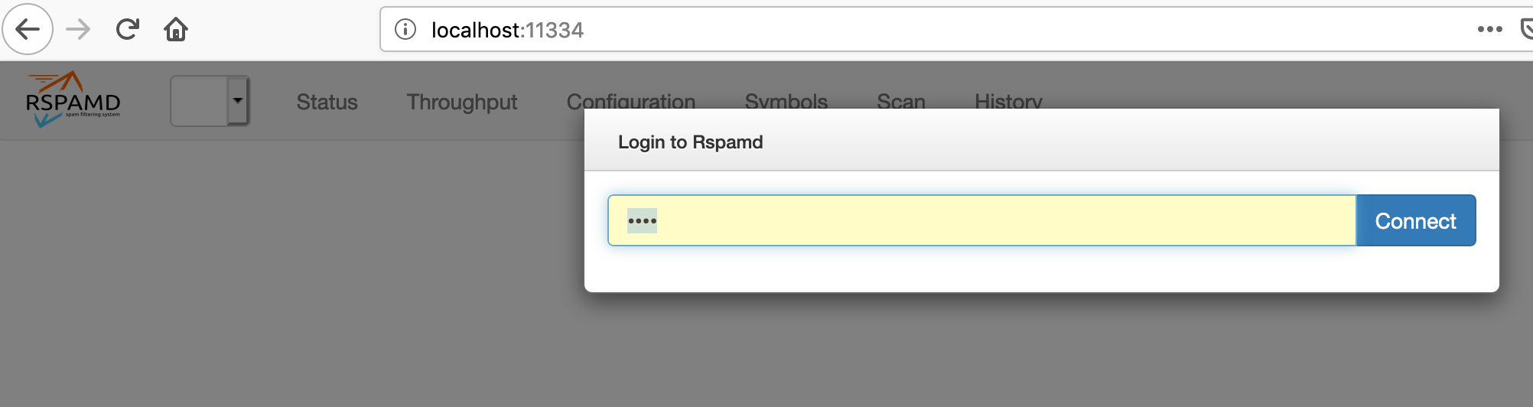

This is the password you have provided in the installation process.

Once you connect Then your spam dashboard will appear.

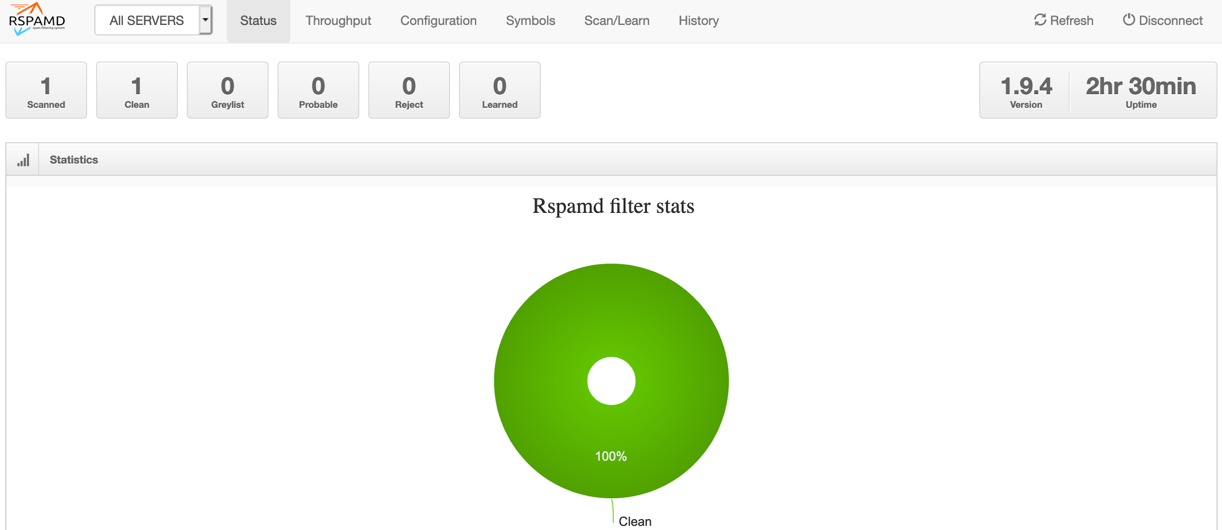

# 

# 

# 

# 5. Installation

Installation Begins with ldap server configuration. In Deployment there may be two test user accounts created in the “ldap.ldif” fine in the deployment folder. First of all these configuration should be imported to ldap server.

First login to the phpldapadmin .

Username : your domain name with admin username :

Ex : “cn=admin,dc=copper,dc=opensource,dc=lk”

Password : <what you have provided in the deployment process “

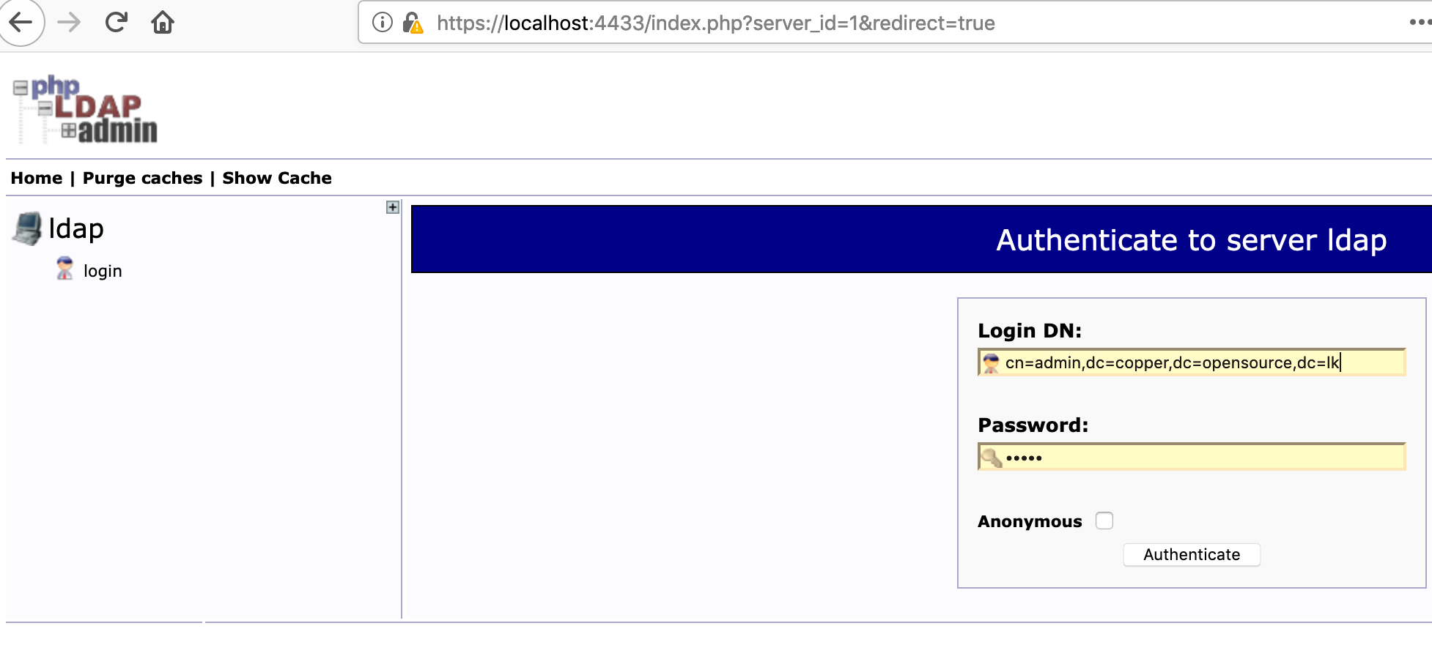

Then import the “ldap.ldif” file in the deployment folder.

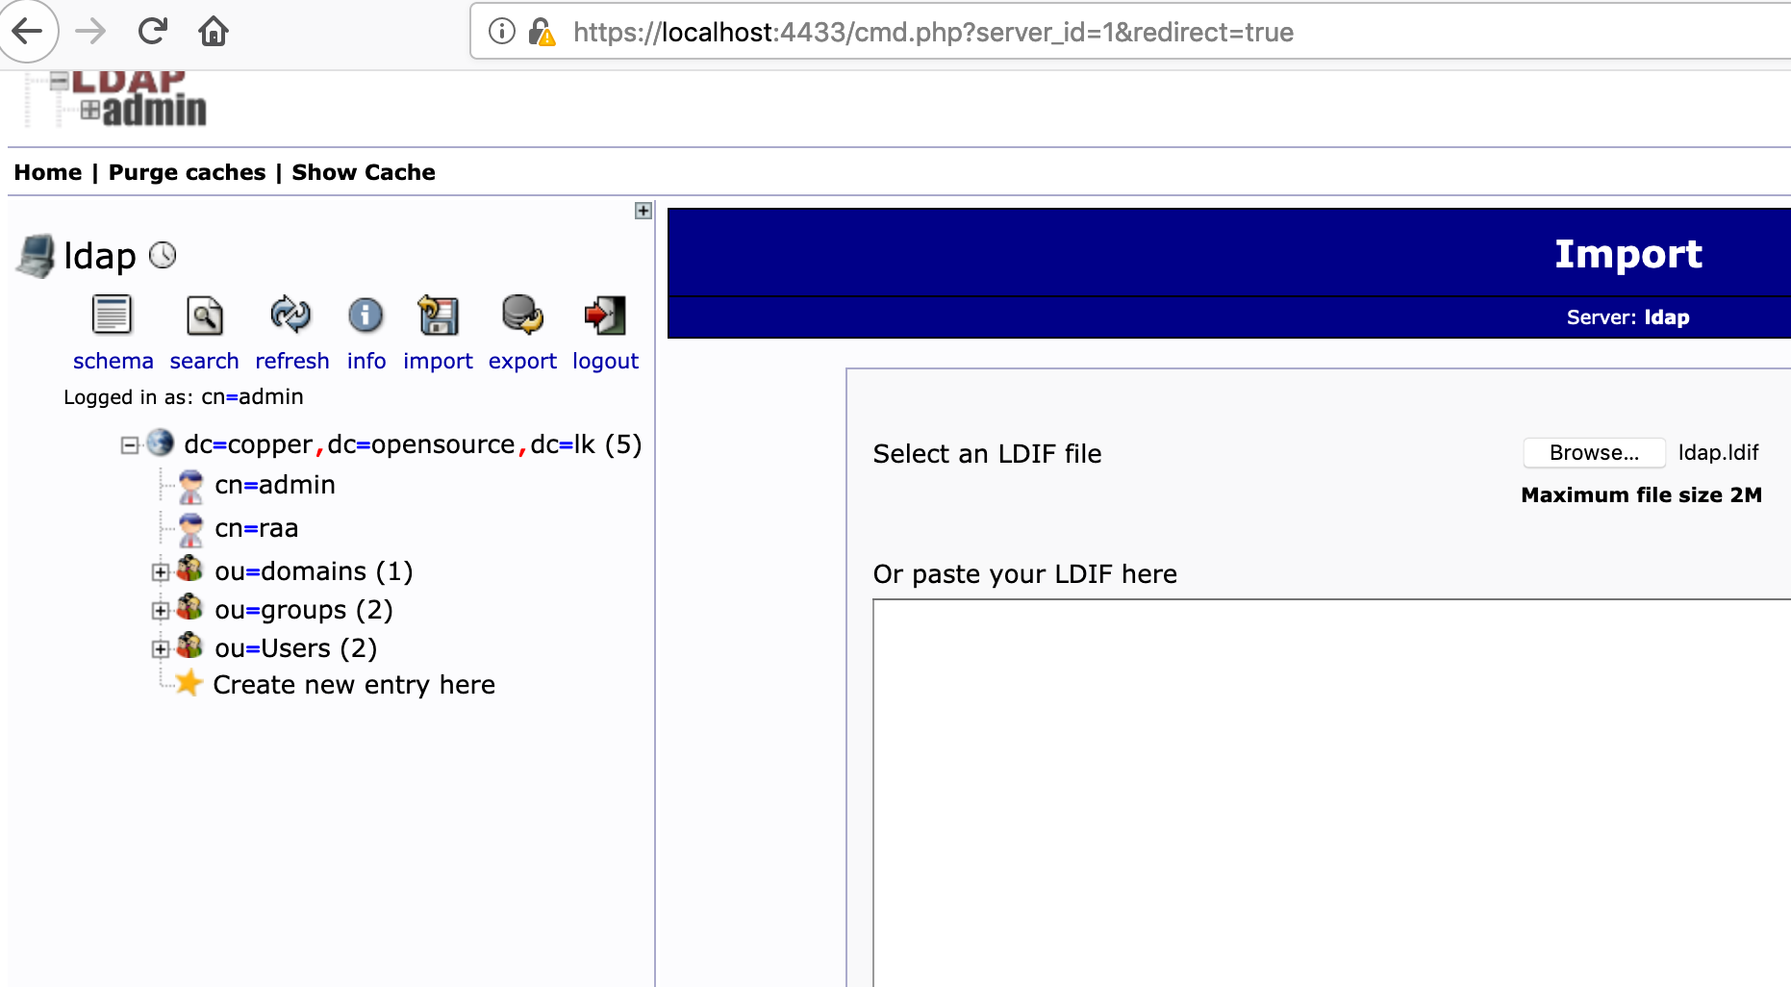

Then your user base is ok and following users may have created.

Ex

Username : copper

Password : coppermail@lsf

Username : test

Password : coppermail@lsf

**Install Group office web client**

Once the user management part is done then web client installation should be started .

Proceed the group office interface installation and press ok for configuration page also and give following parameters too.

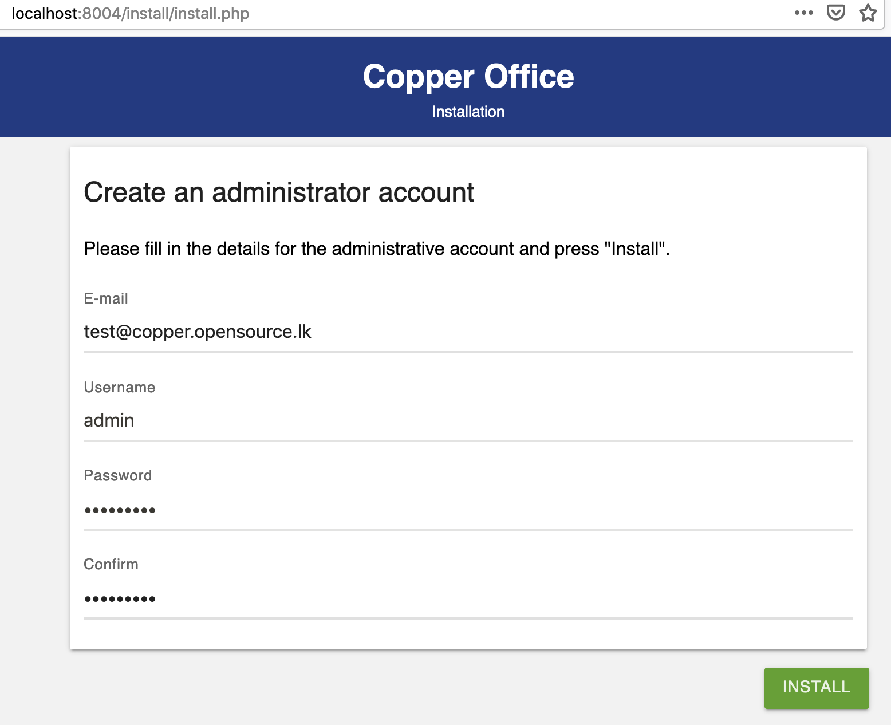

This is the admin account password and you have to remember it for further logins.

Once Installation completed then try to log in again with given username and password.

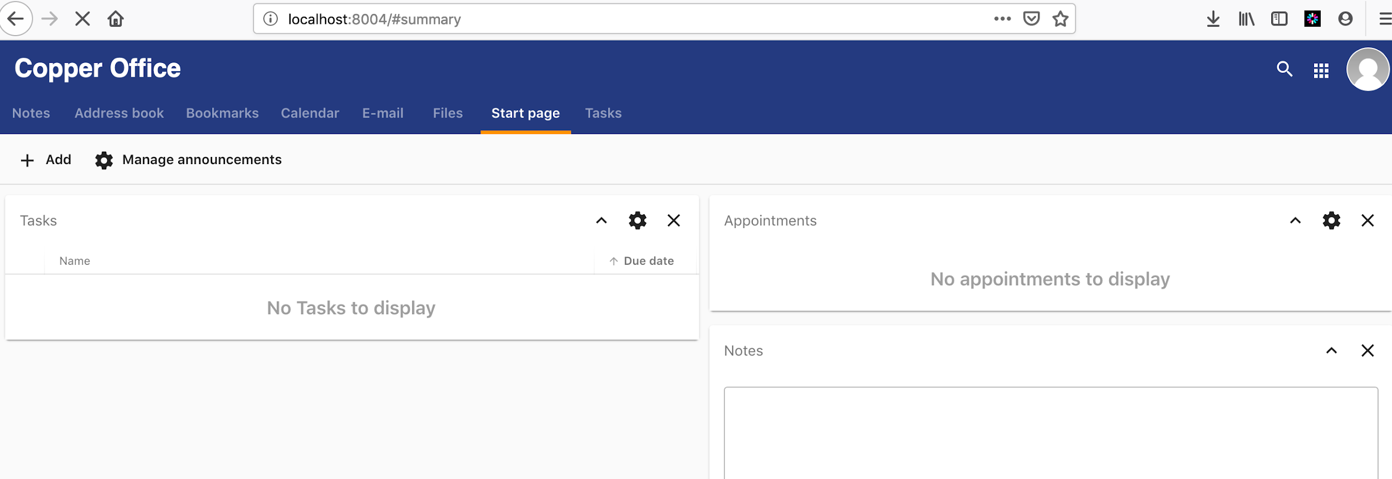

Add ldap module

Again logout and login again.

Click on “Modules”.

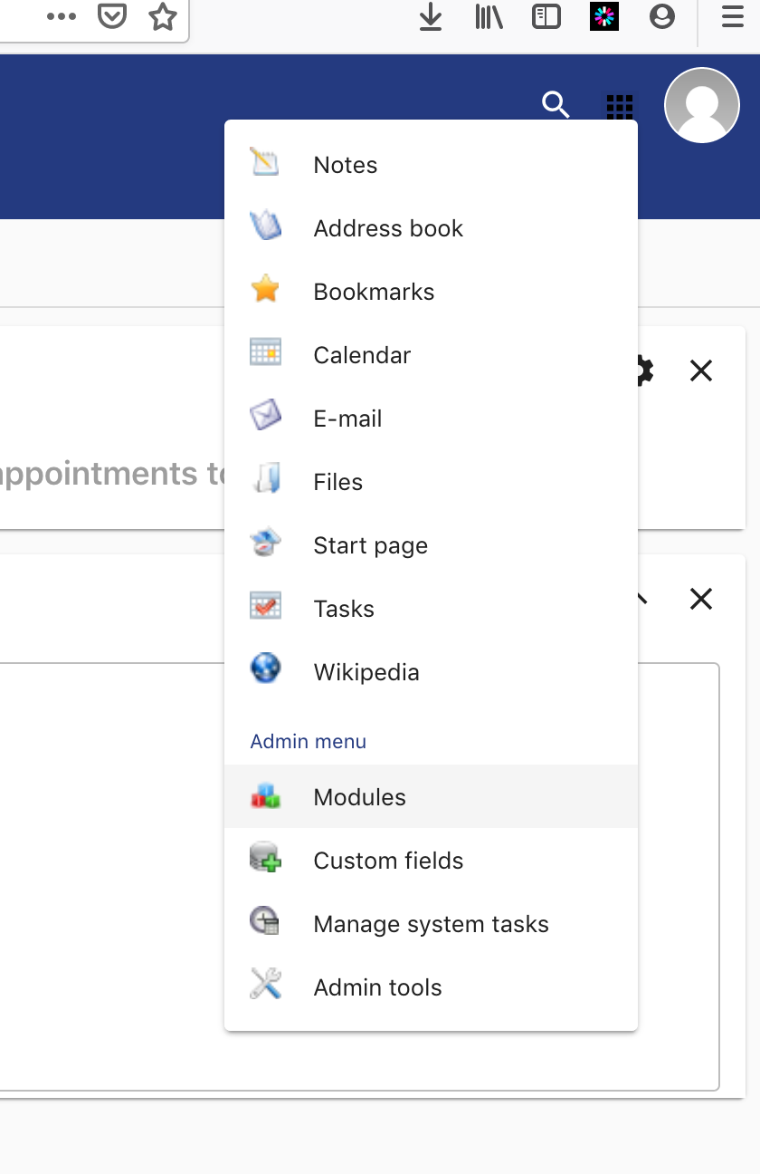

Then add the ldap plugin from the community section and then add the admin user also.

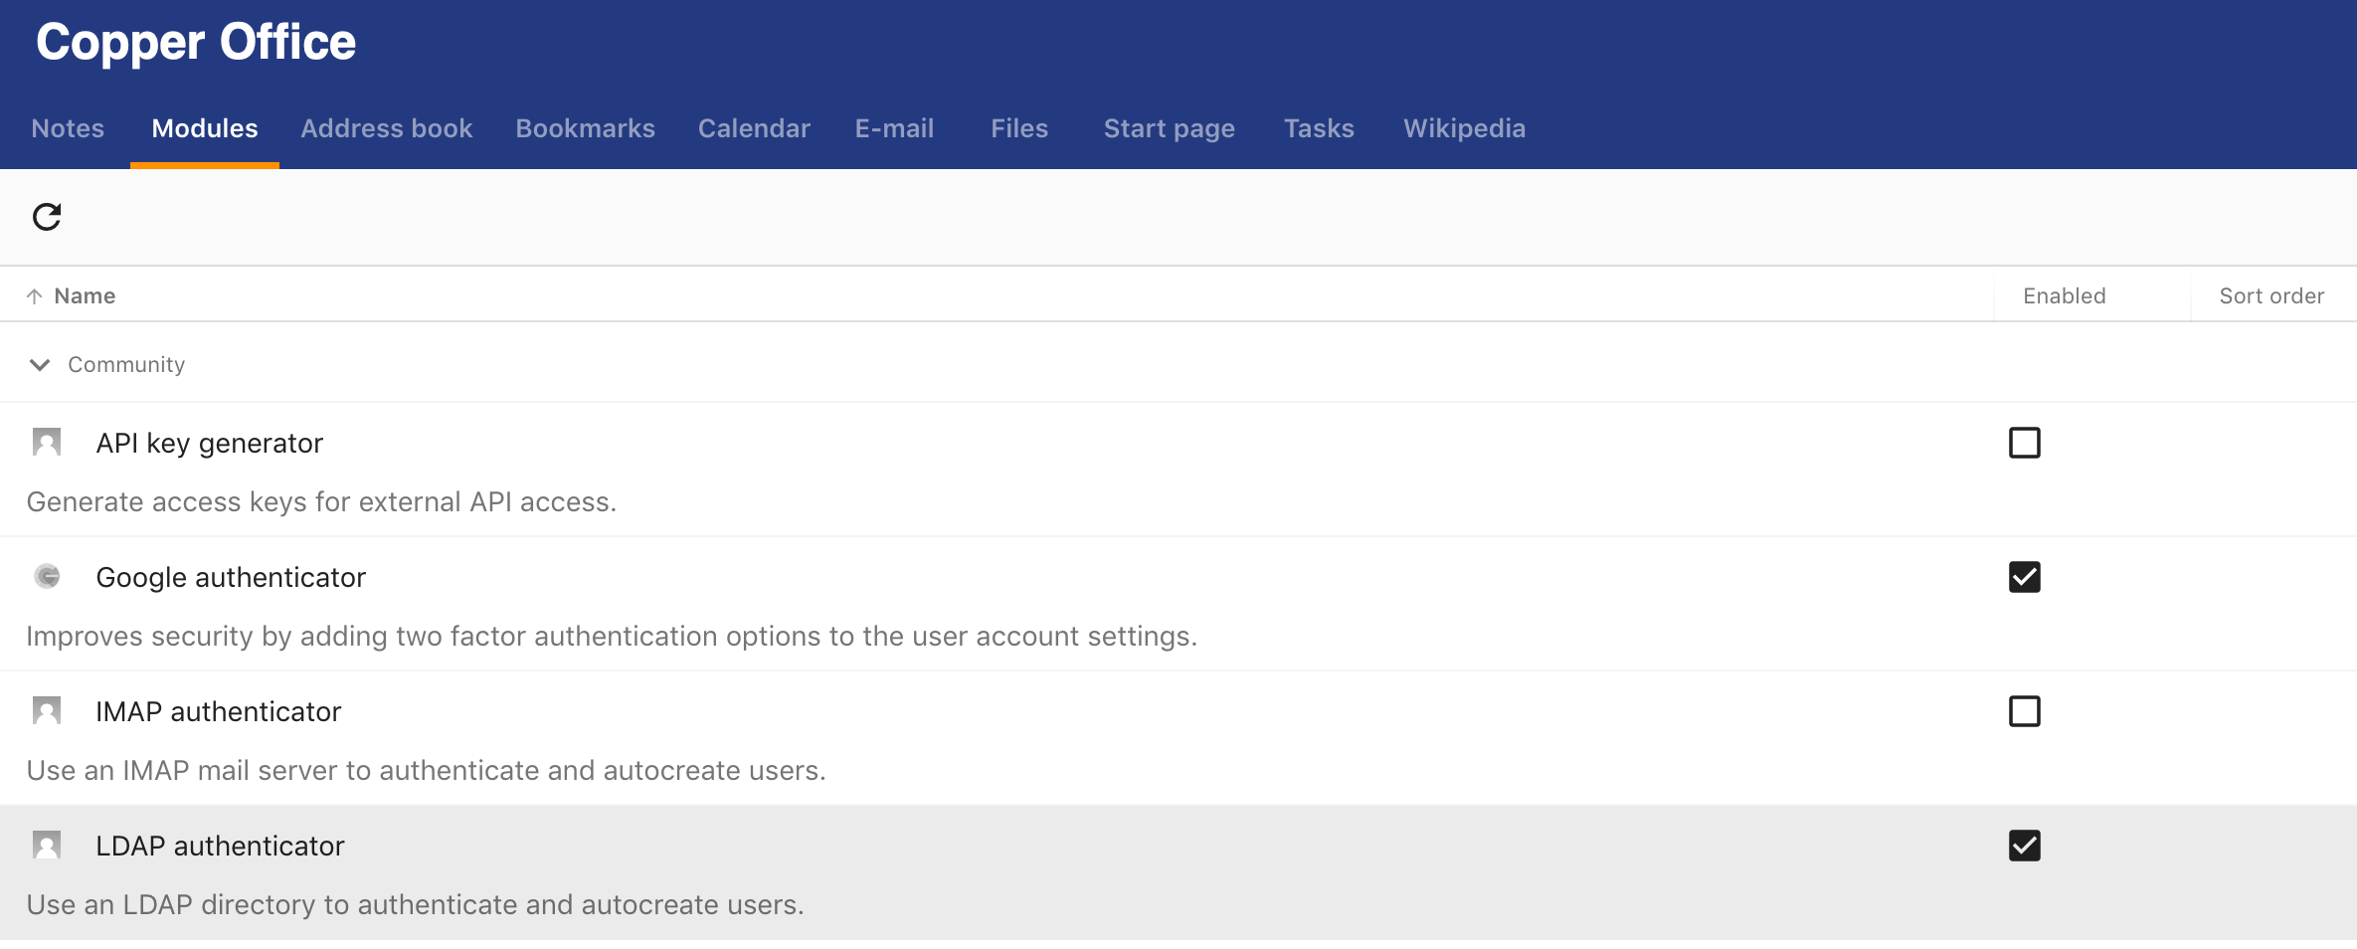

Then log out and log in again.

**Configure your ldap server.**

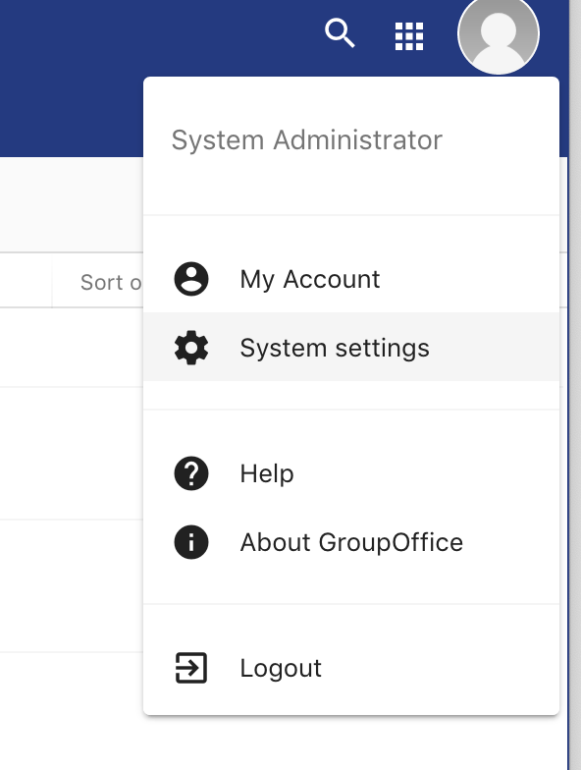

Go to System settings and then go to Authentication.

* For ldap server

Fill following details as given in the example.

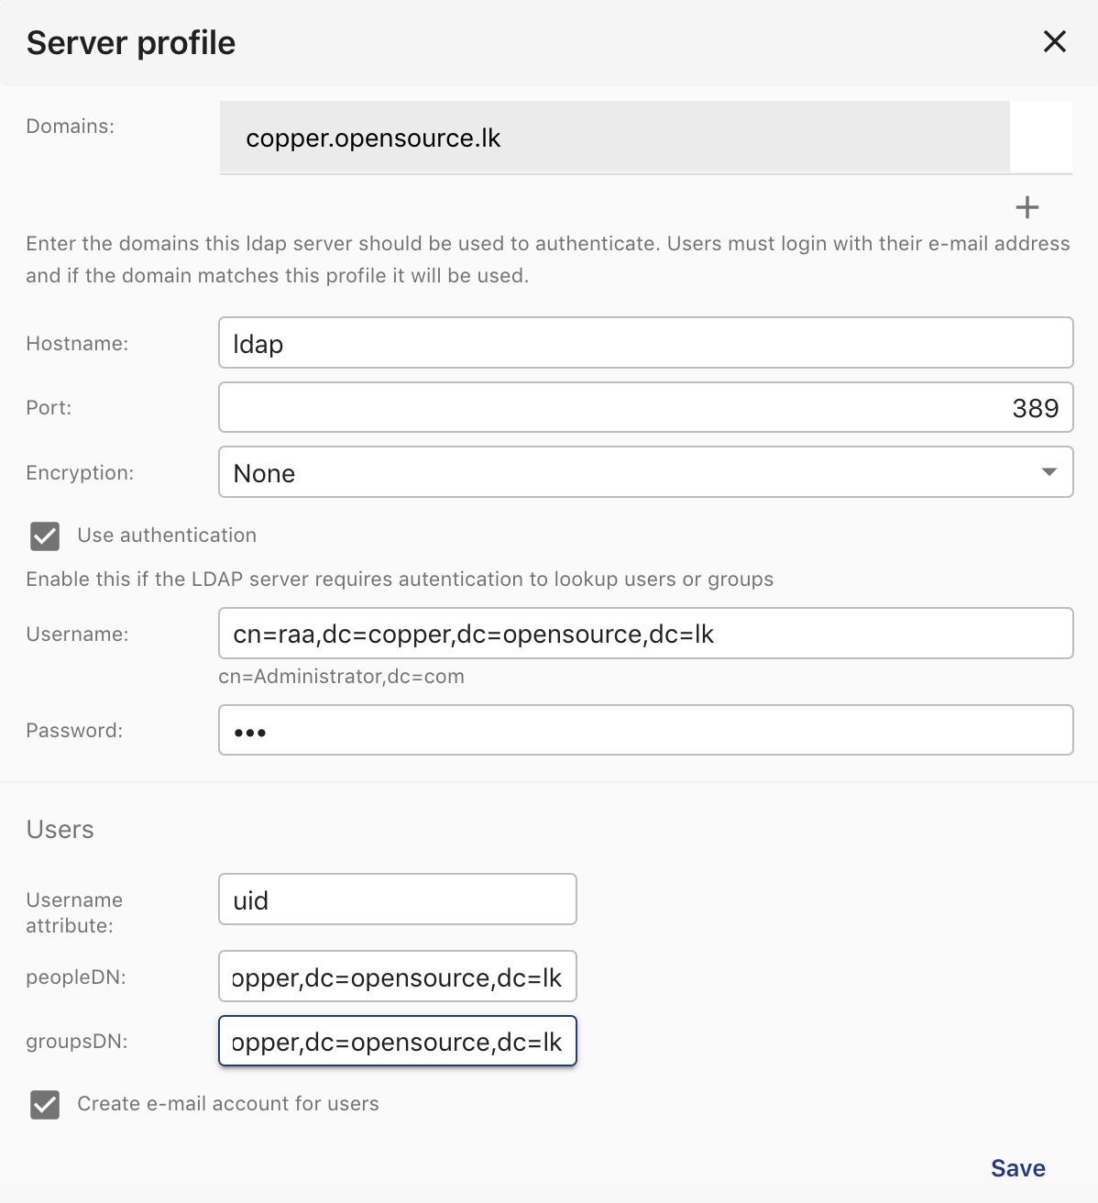

Then you have to provide your email server details as follows.

These information should be given as same given in the example because those information about your email server container.

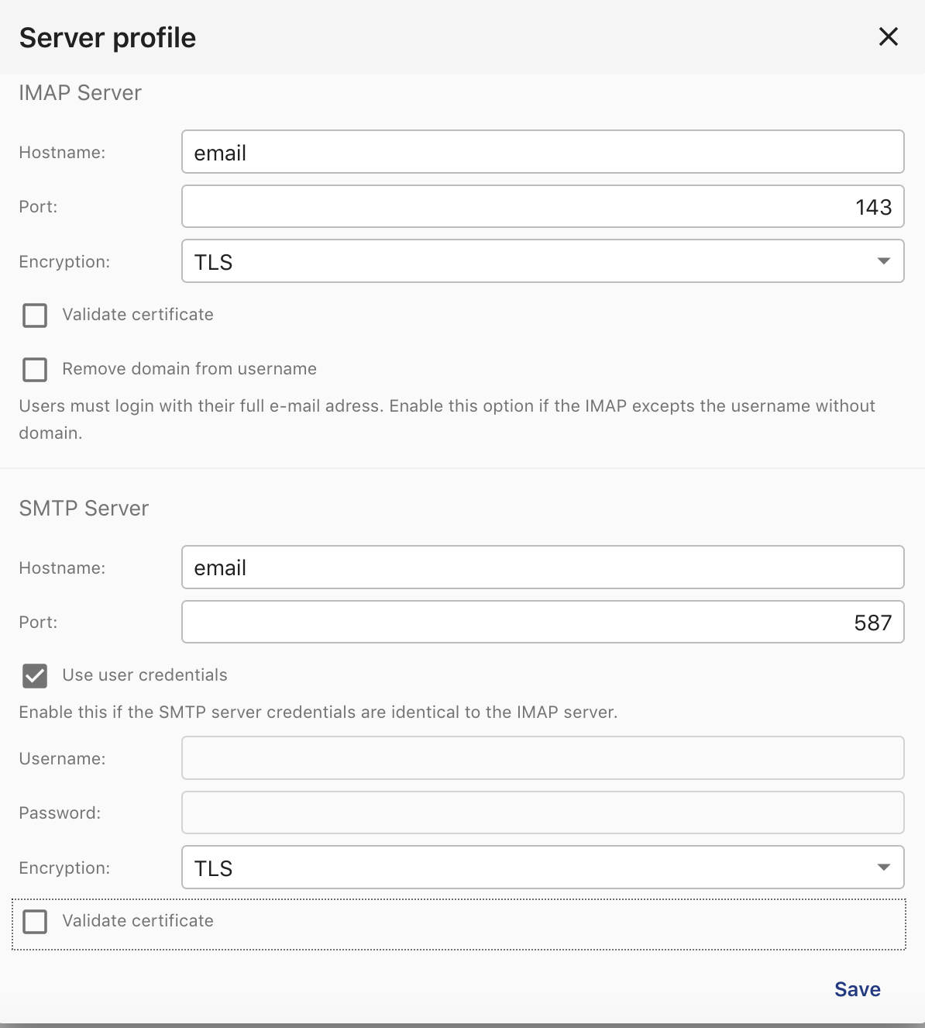

Finally add to Internal group and then save.

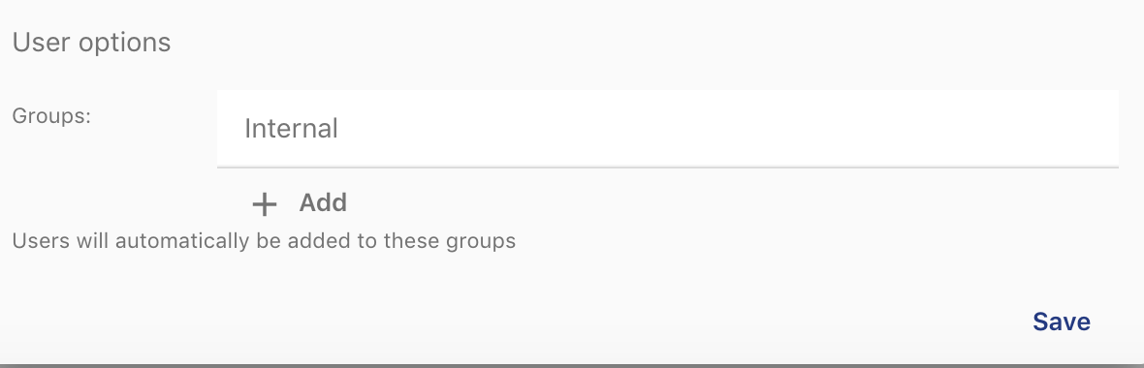

Then again logout.

# 

# 

# 

# 

# 

# 

# 

# 

# 

# 

# 

# 6. Functional Testing

Once completed above all steps then you can start your functional testing.

1. Login to you domain.

http://localhost:8004

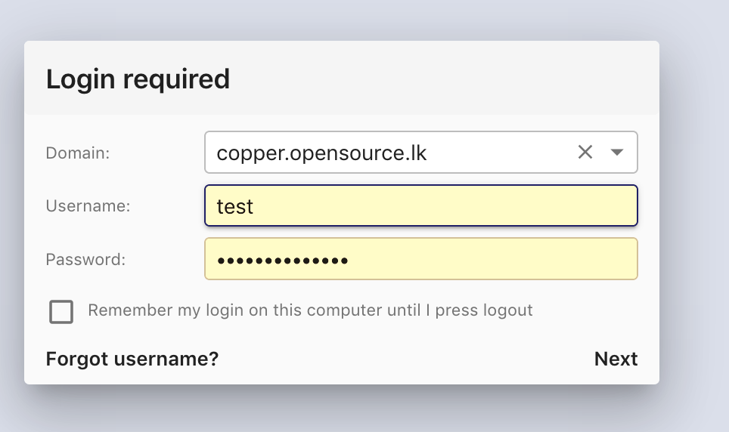

Now you can select your domain and login with test user account or copper account (both password is coppermail@lsf).

Successful login will bring you the dashboard. Then click Email tab.

If Email connectivity is success your folder structure will be shown as shown in bellow image.

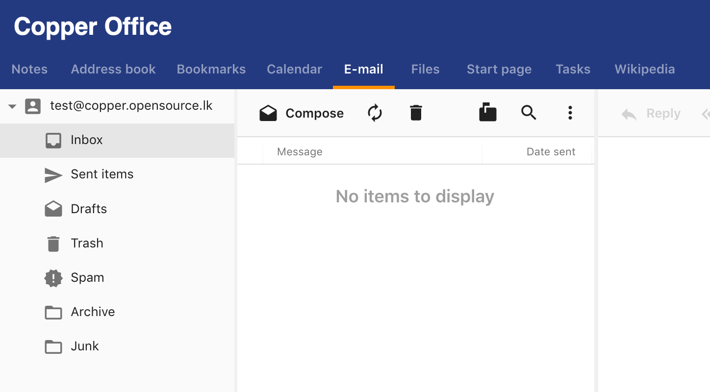

Then try to send a mail to yourself to check mail sending and receiving in same domain.

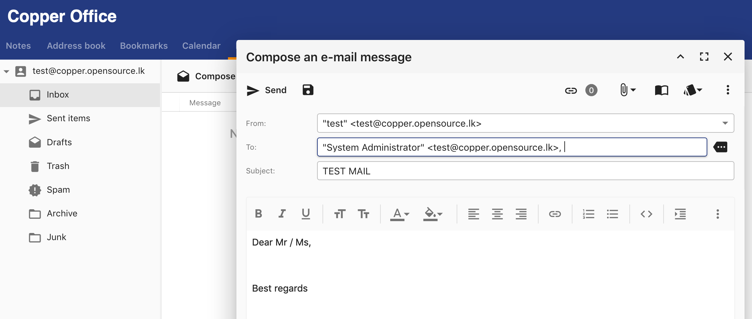

If mail sent then popup close and receive also should happen properly.

# 7. Result

